**Question 1**

1. Ensure your region is set to “**N Virginia**”.

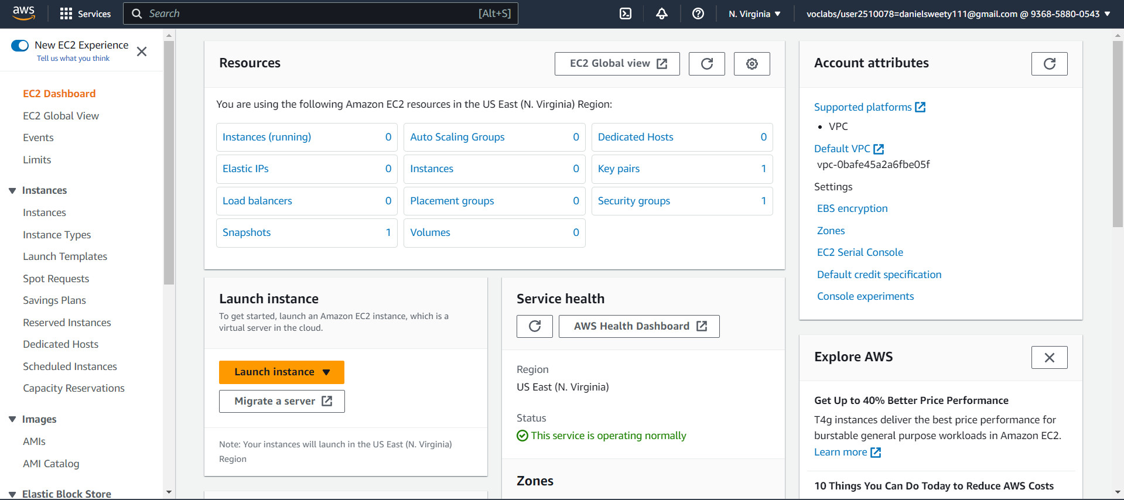

1. Create 1 EC2 instance using the 7 step workflow.
2. Use the usual Amazon Linux AMI in AZ1

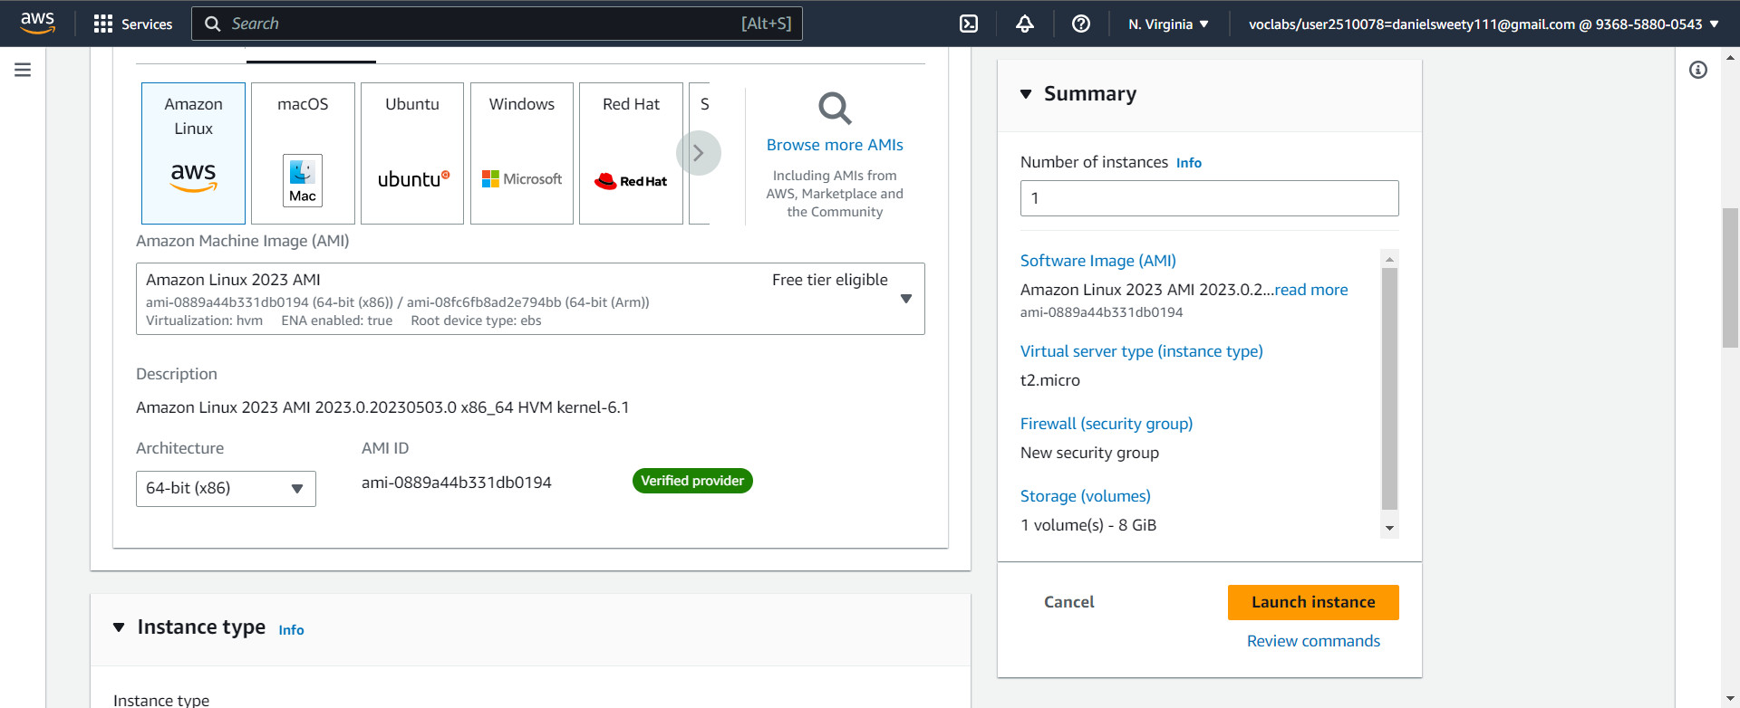

1. Download a new PEM File and SSH to the instance

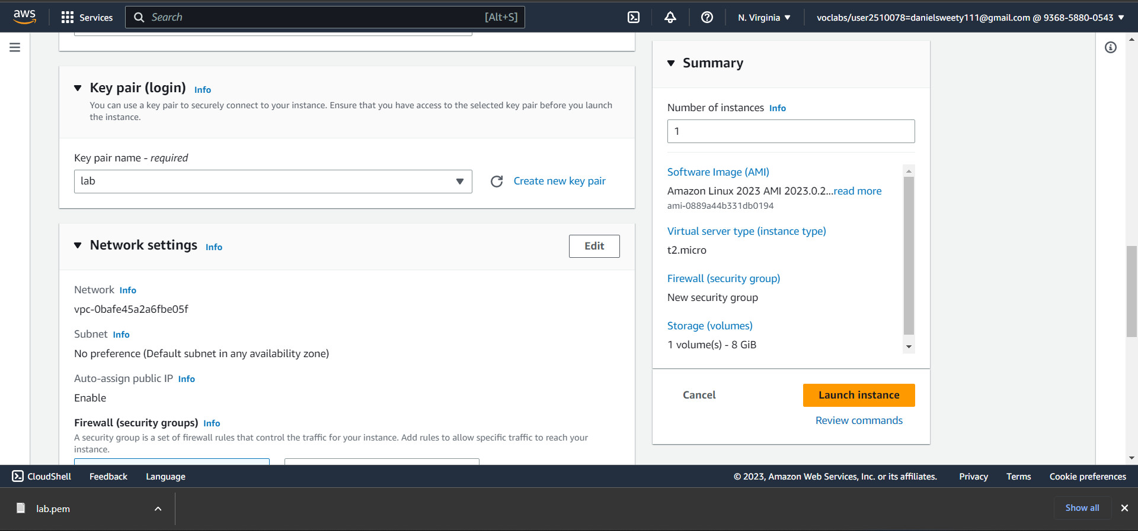

1. Volumes
2. Use the console to get a 10G magnetic volume in the same AZ1

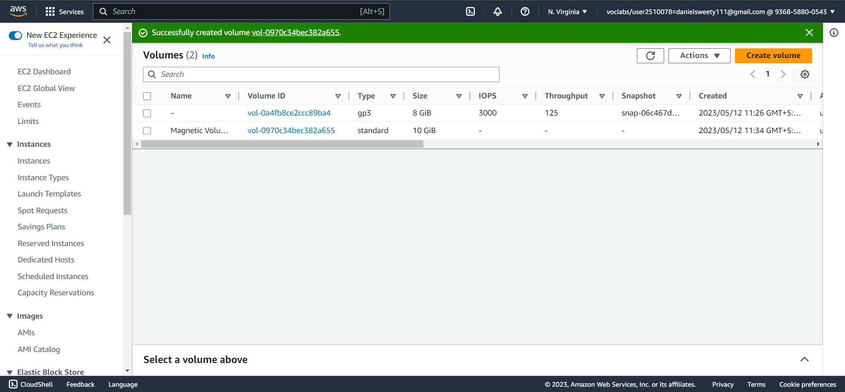

1. Attach the volume to the instance

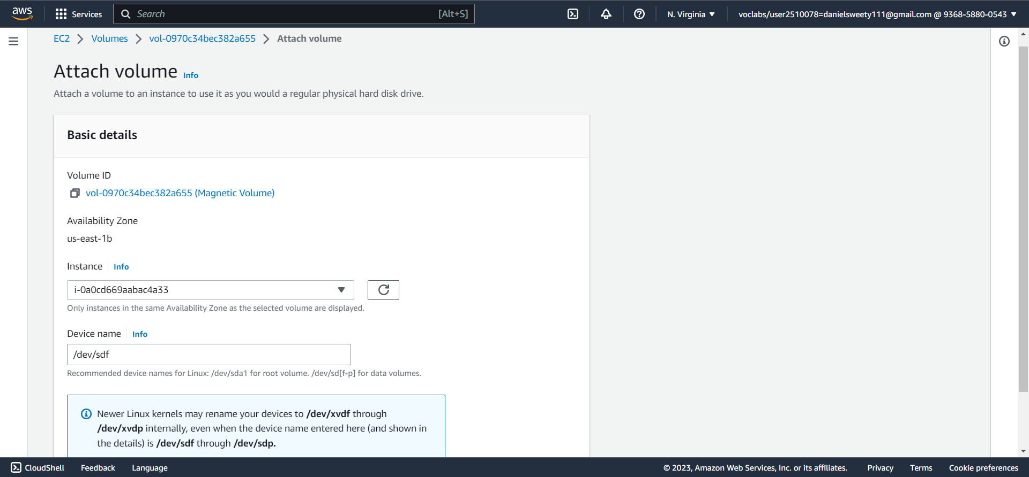

1. Format the volume and mount it.

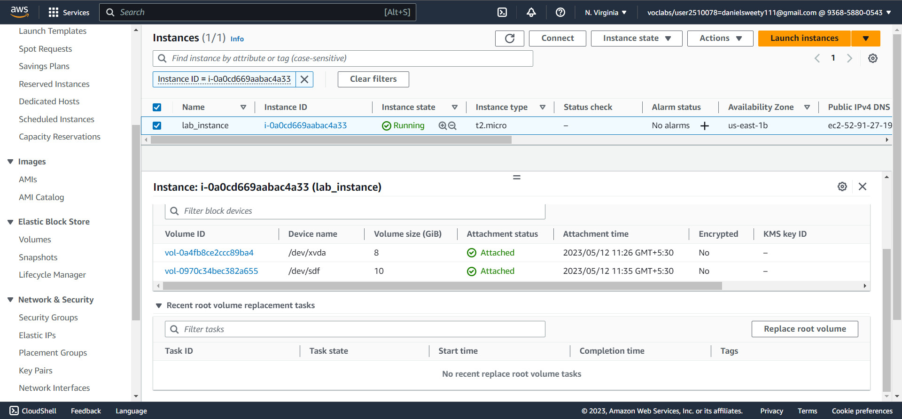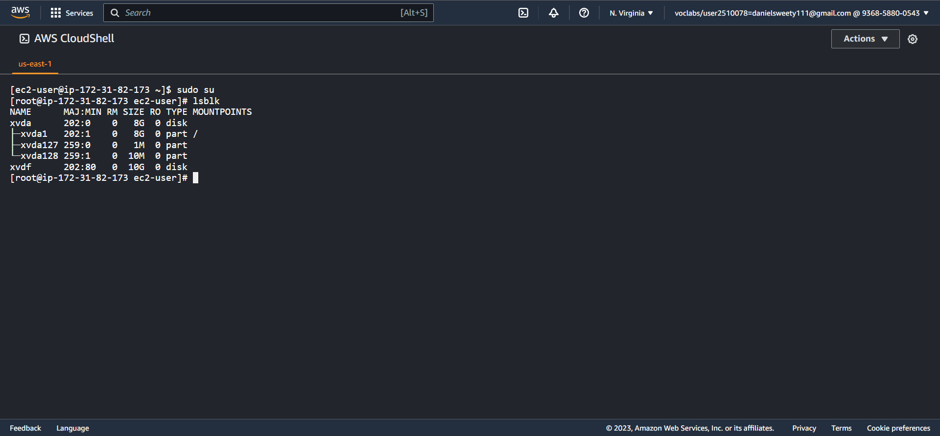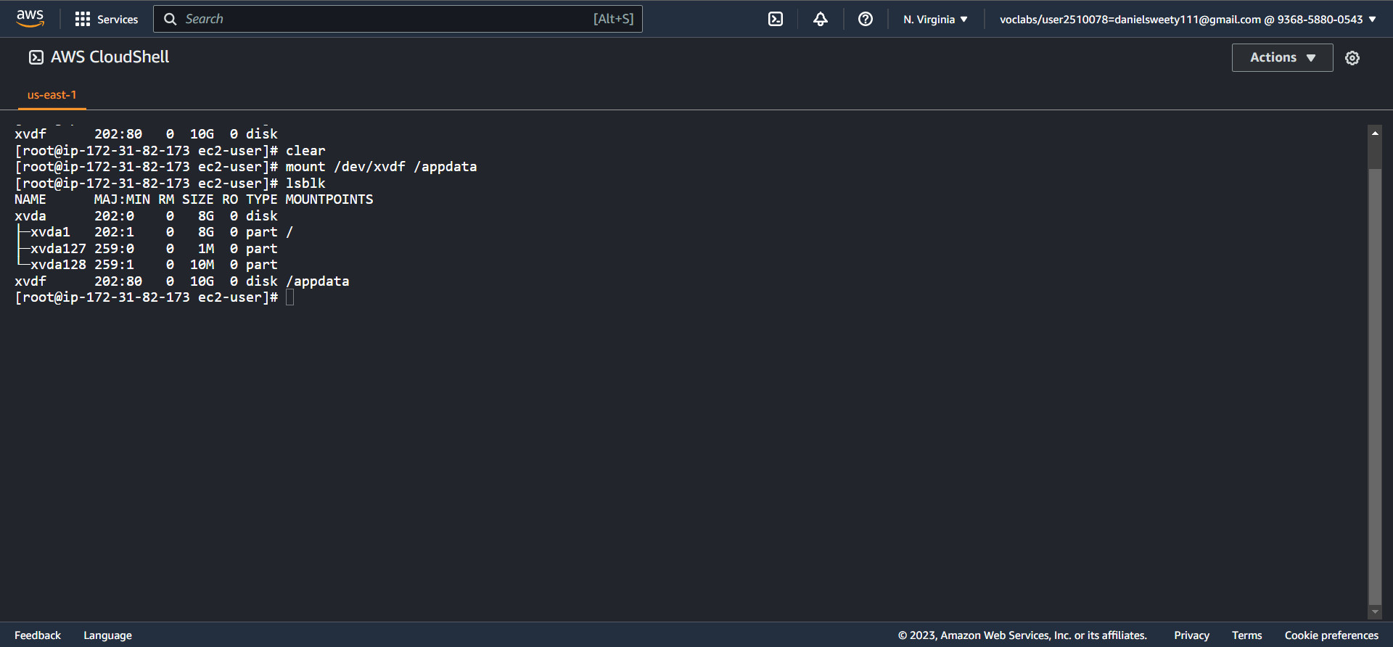

1. Create a sample text file in the volume to simulate data creation

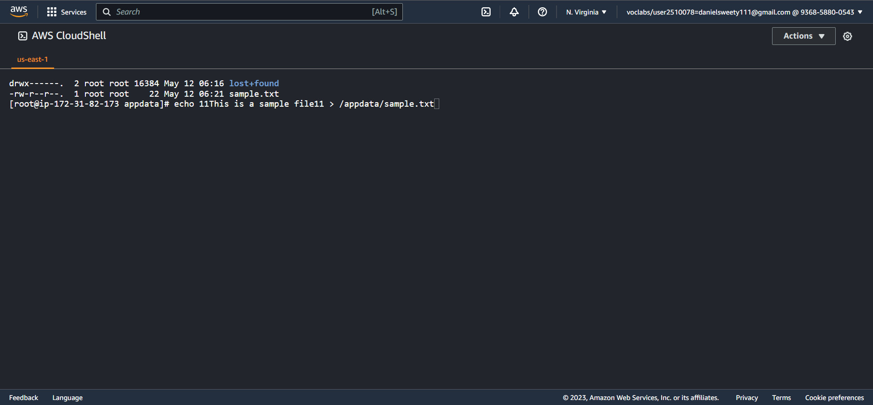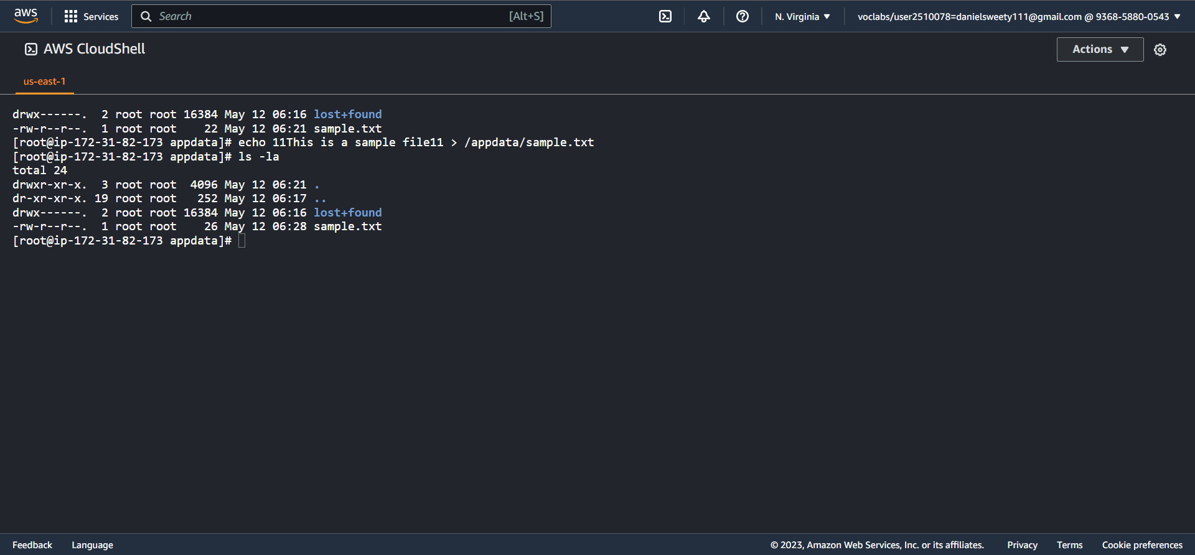

1. Unmount, detach the volume.

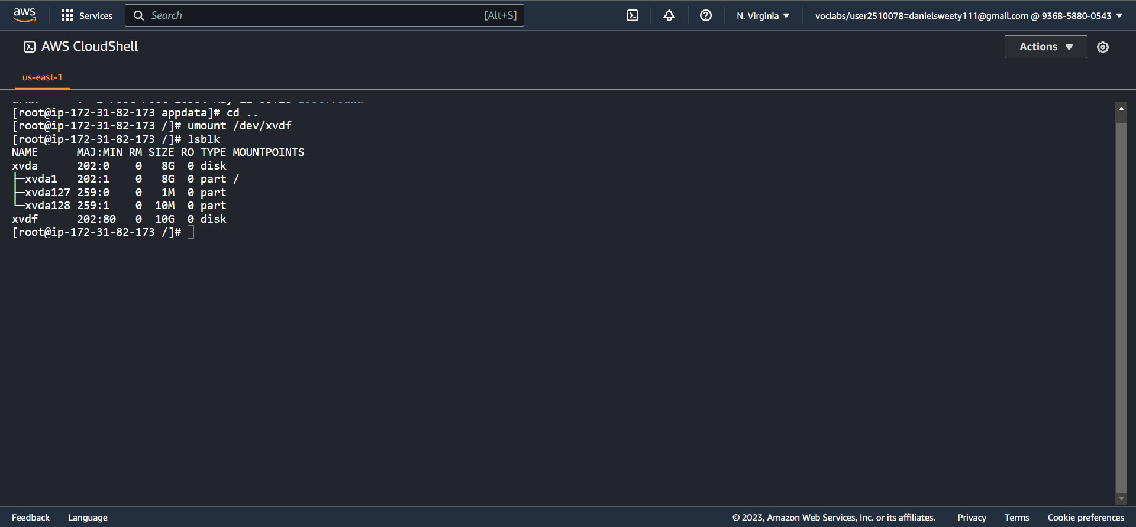

1. Snapshot
2. Create a snapshot of the detached volume
3. Create a new SSD volume of 10G and apply the snapshot to it.

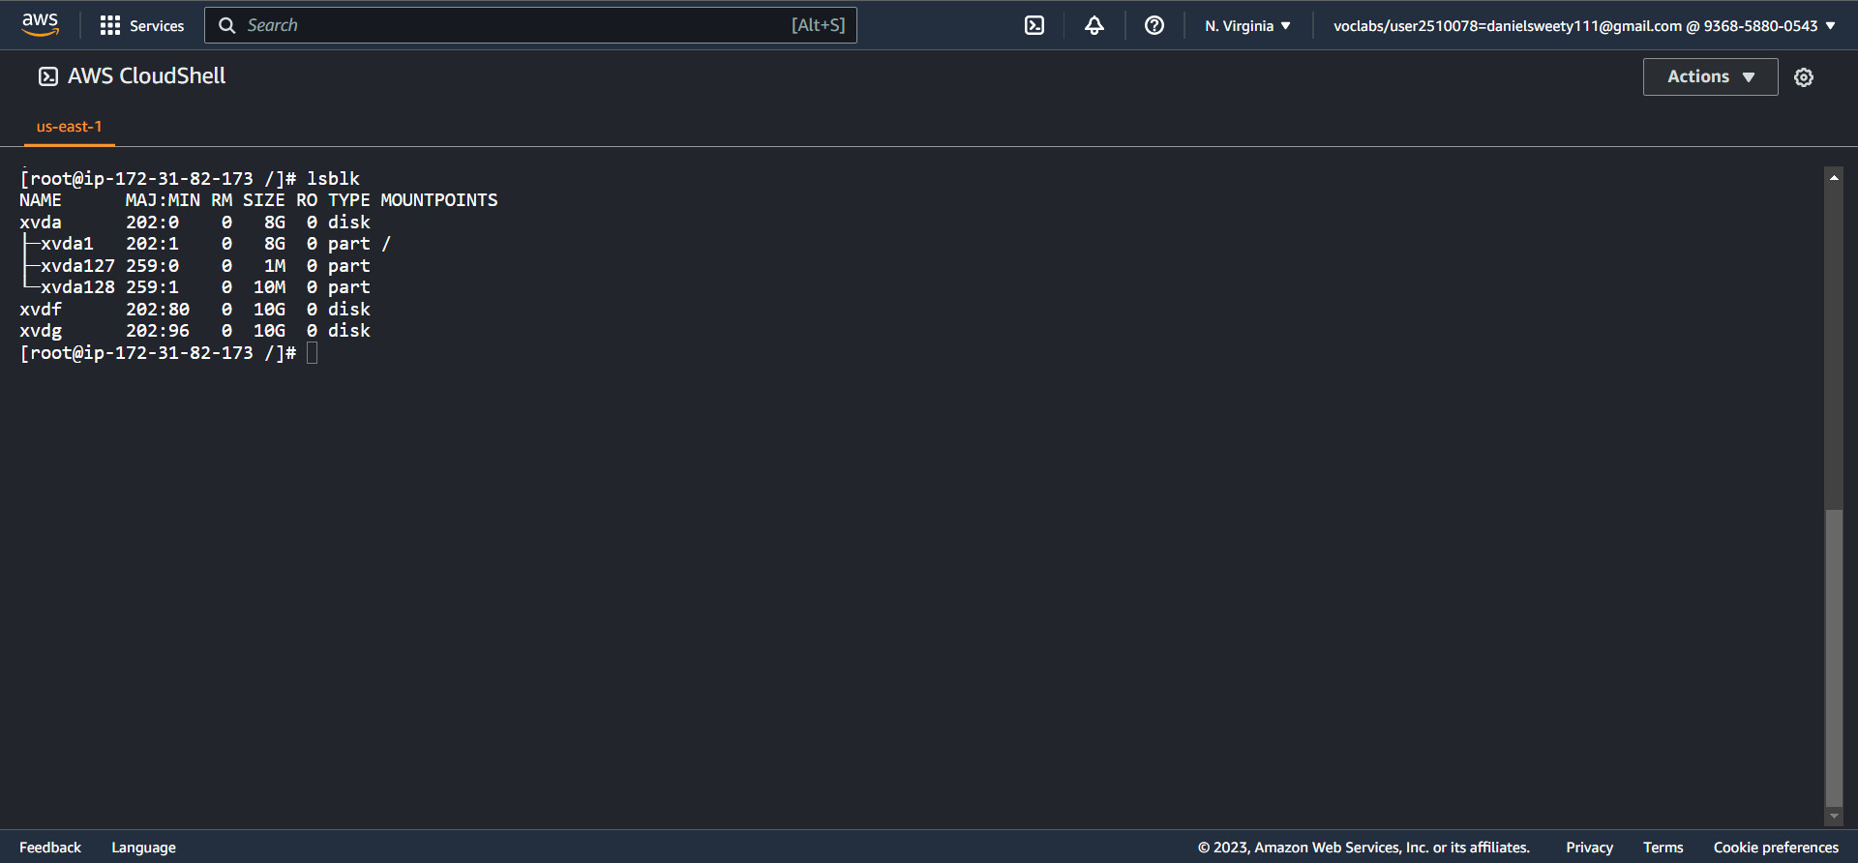

1. Attach, mount and check if the data is there.

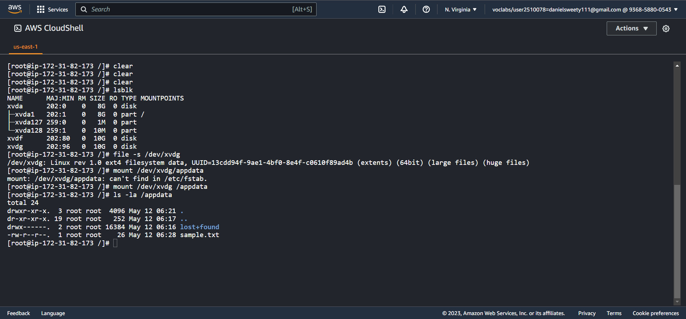

**Question 2**

1. Use the S3 browser console to create a bucket that is unique to the region

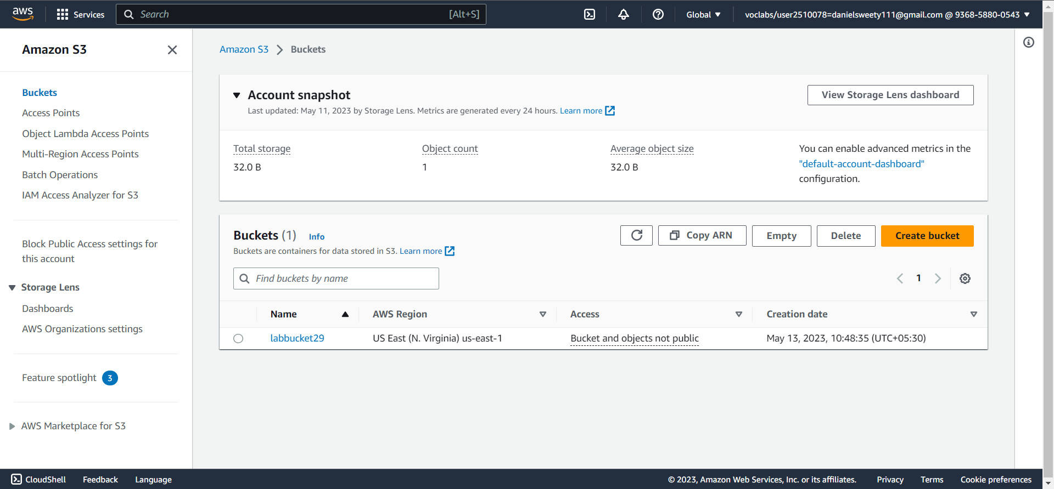

1. Use the CLI to:
2. Upload a few(non sensitive) files from your local machine to S3 bucket

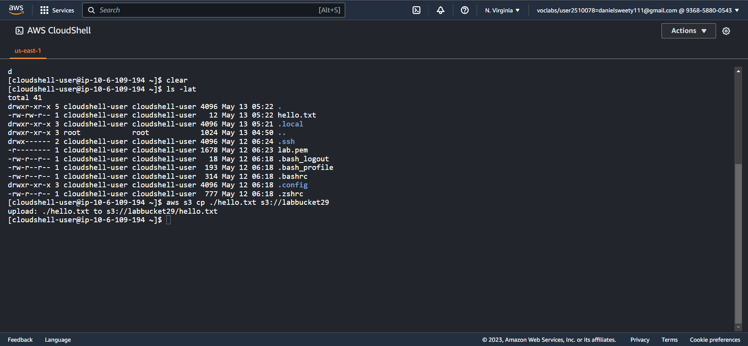

1. List the bucket
2. List a contents of a bucket.

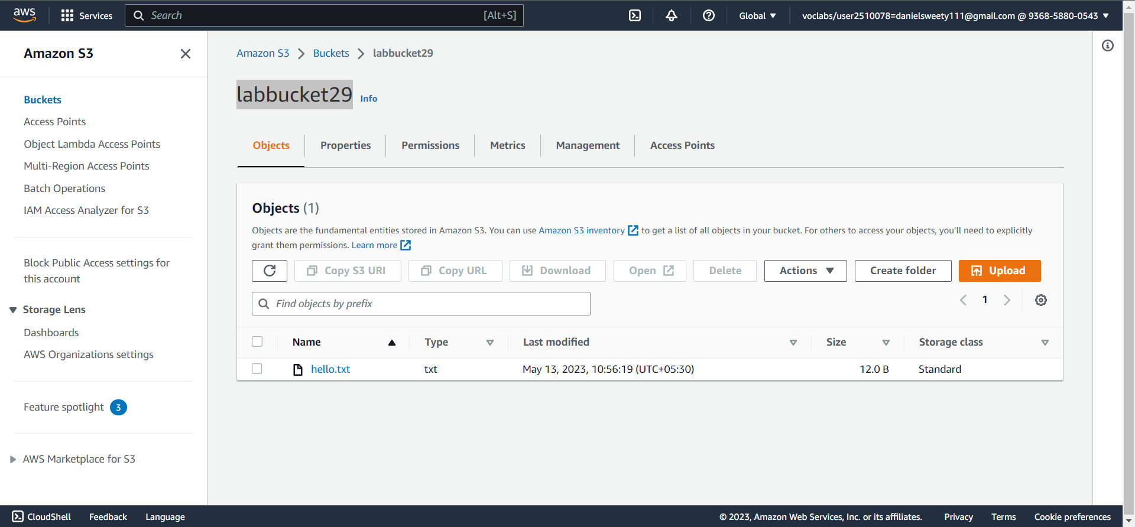

1. Enable versioning of the bucket

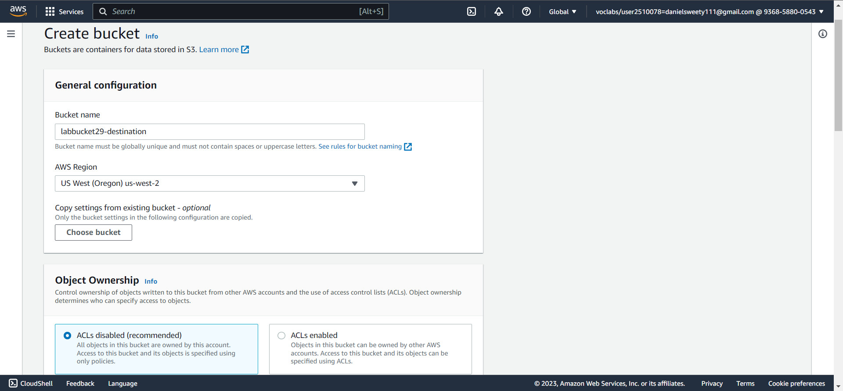

1. Enable cross region replication

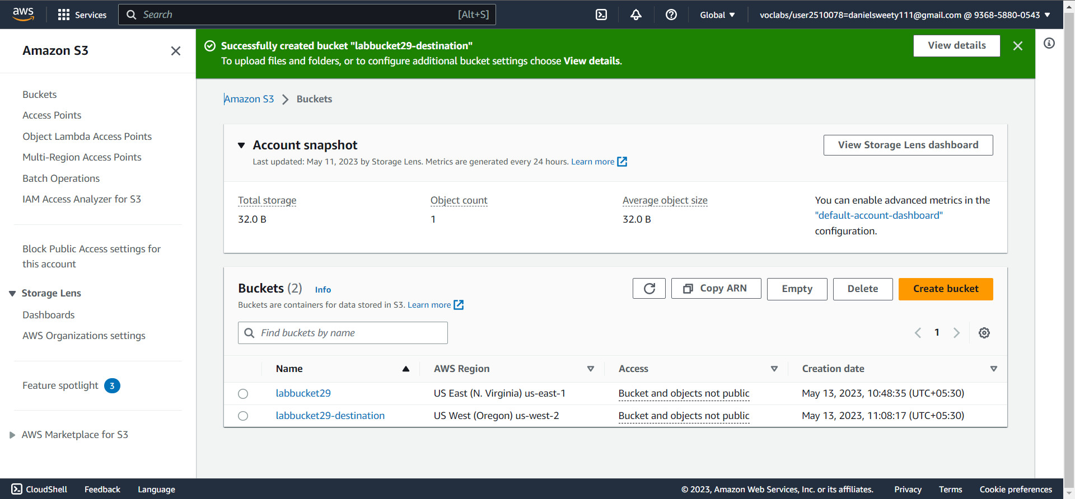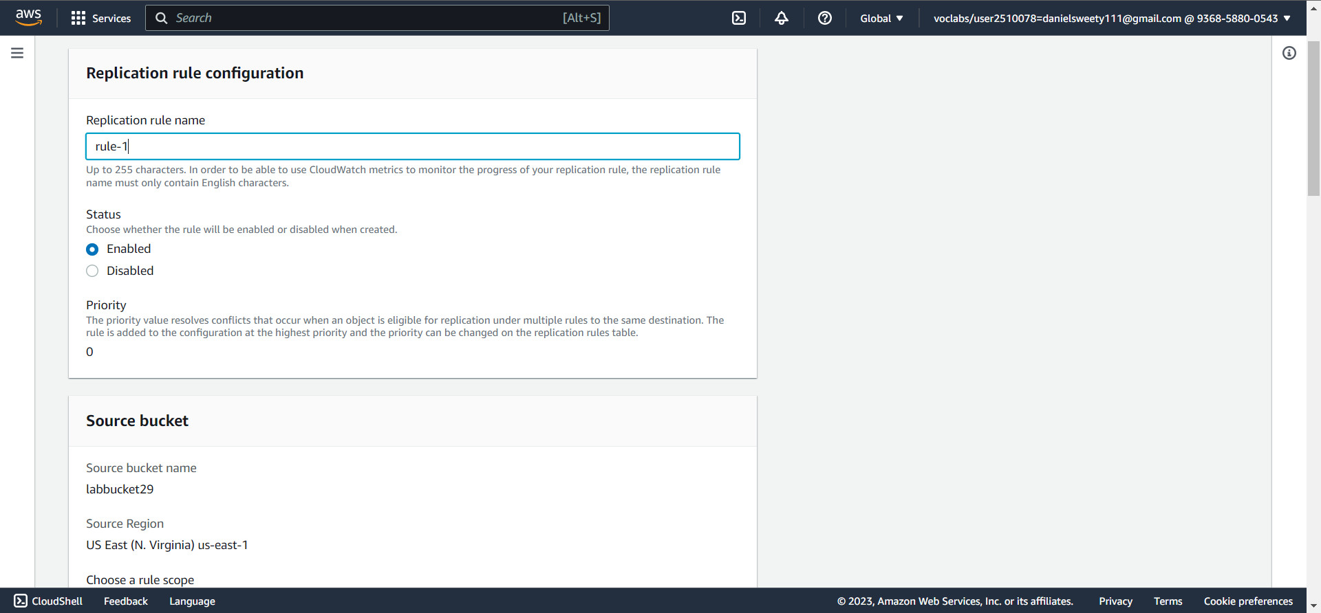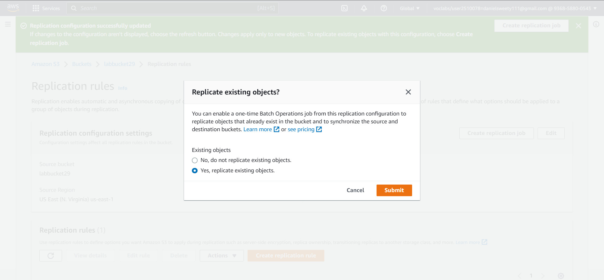

1. Q: State your observation of the existing object(are they replicated?)

Yes, The hello.txt file has been replicated from the **labbucket29** to **labbucket29-destination** as hello1.txt file.

The content inside hello.txt will be copied same as in hello1.txt.

1. Using the CLI, upload a few new files to the same bucket

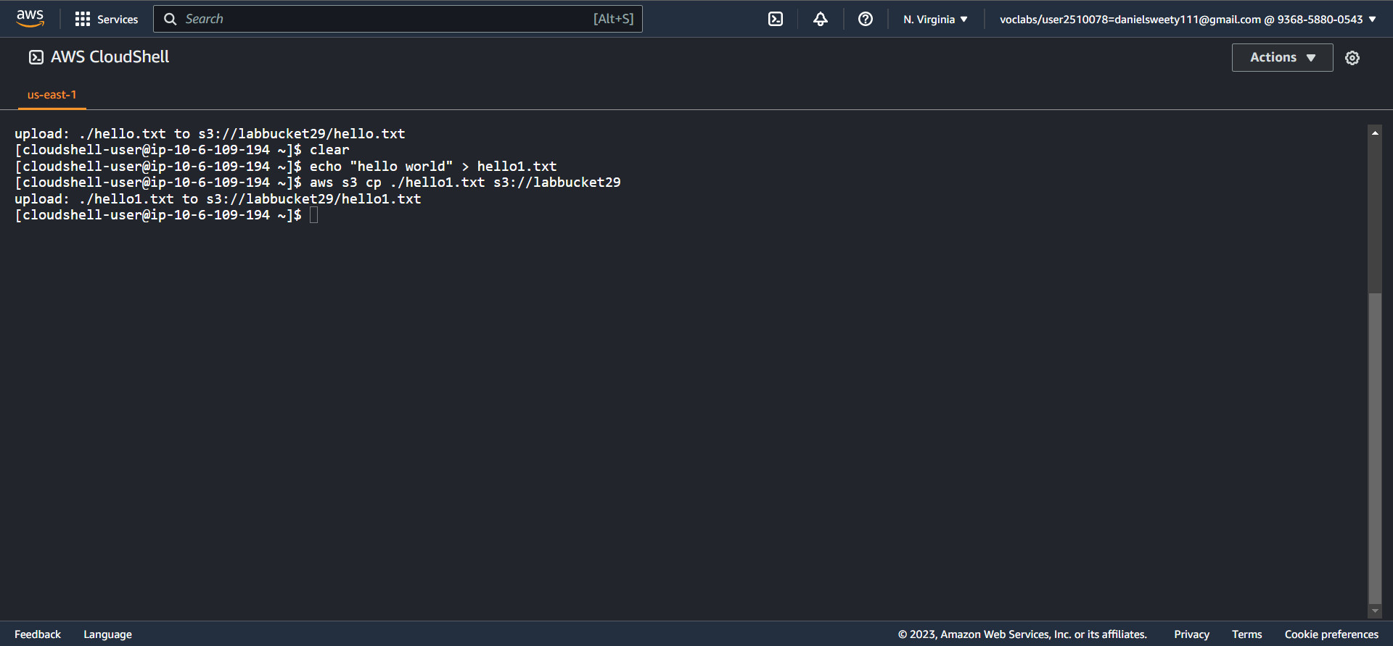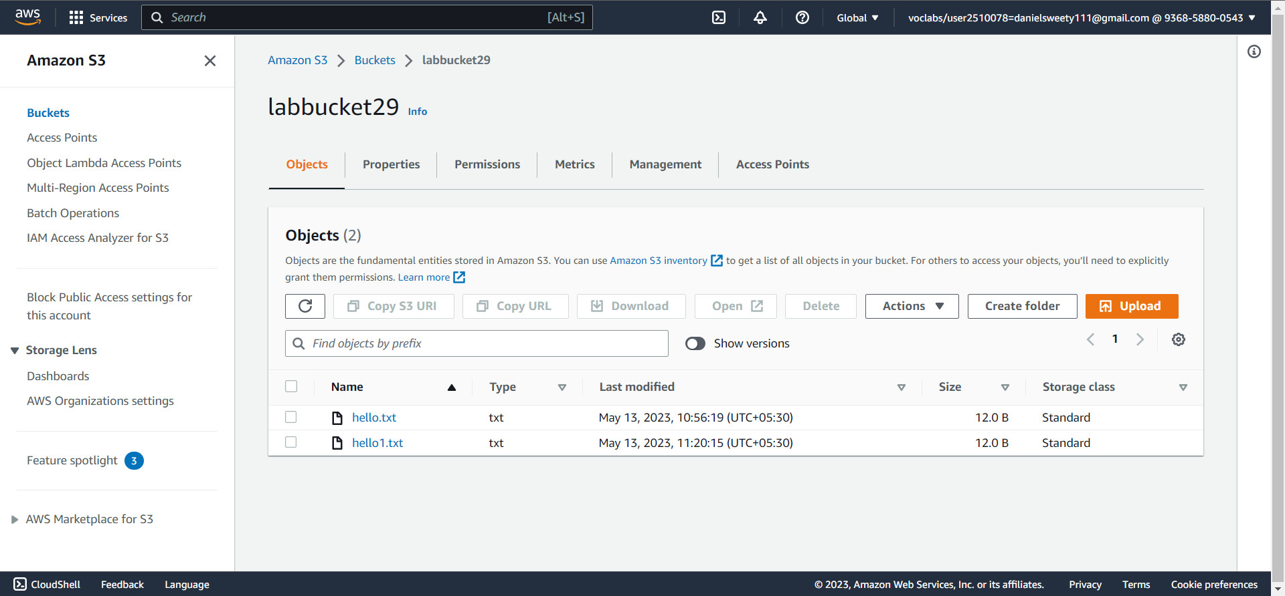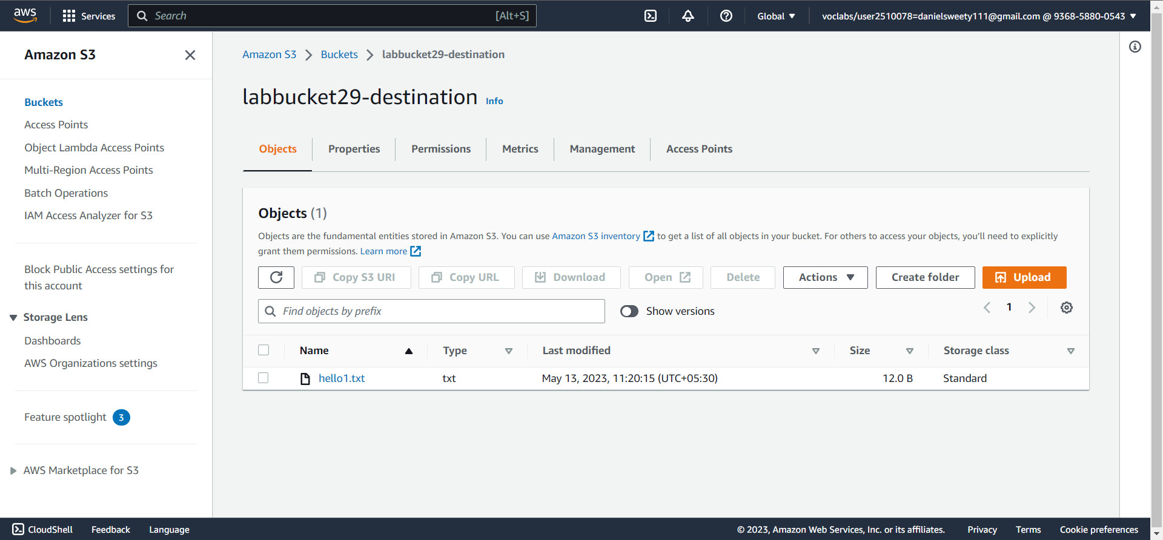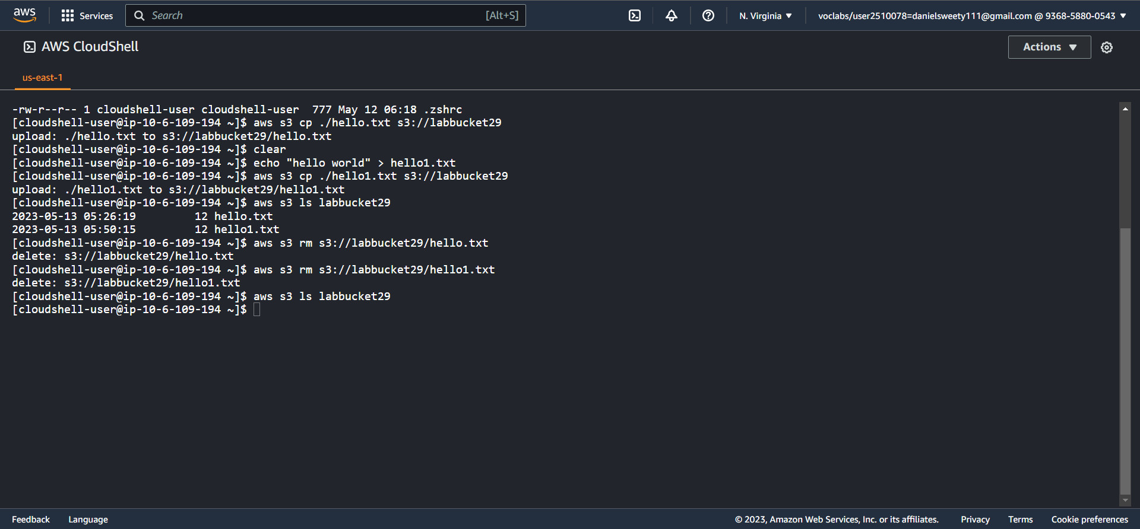

1. Q: State your observation of the new object

The new object which is derived from the existing object it is a replicated from hello.txt. And it is an updated version of existing object. It can be updated and it will not affect the old object.